## **Deep Learning Surrogate Model** Research Diary and Journal LaMEP - Rafael Magalhães

Started in 01/11/2019

This document was created to register and make it easy to share important perceptions, decisions, insights, and comments regarding to the experiments related to my thesis. It is supposed to be written in chronological order but relative to each subsection of the document. It isn't written in a article/paper structure but it's supposed to be easy to portable or feed articles/papers.

## Summary

Dataset Description

Experiment 0 - Proof of Concept

Experiment 1 - DNN

Experiment 2 - CNN

Experiment 3 - RDNN

## Dataset Description

The original plan was to make a proof of concept for the proposed methodology with a small synthetic model of reservoir and, with the confirmed hypothesis, doing the experiments with a larger and real based reservoir model. For the proof of concept was defined the SPE 9 model and for the subsequent experiments the UNISIM-I model.

#### DS1 - SPE 9

The SPE 9 model was created to challenge the oil/gas reservoir model software developments as a benchmark. A very well description about its properties and characterization could be find in the paper of Killough (1995) entitled "*Ninth SPE comparative solution project: A reexamination of black-oil simulation*" [doi:10.2118/29110-MS].

In general lines the SPE 9 is a grid of 24 x 25 x 15 (as layers) cells, in a total of 9000, represented as cartesian grid. The model was defined to operate before its depletion during 900 days, with 25 producers wells and 1 injection. The following images extracted from [https://www.sintef.no/projectweb/mrst/modules/ad-core/spe9/#7] represents some properties of the model.

|  |  |  |
| --- | --- | --- |
| Horizontal Permeability | Porosity | Initial saturation Oil and Water |

The CMG Software Pack was chosen to run the model based on the files distributed by Petrofaq [<http://petrofaq.org/wiki/IMEX_Dataset_Example>]. In this dataset model, they assume a priori position for producers wells and injection just like presented in the follogin image [same source from previous]:

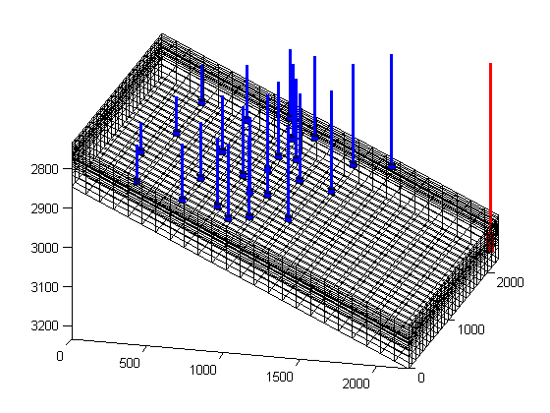

In order to make the first experiment it was decided to remove the injection well, and make use individually of each well position already informed. In this way, will be generated 25 simulations. All the wells will be conditioned to the same controls and pressures (BHP). The objective is to understanding the reservoir response for each natural/primary case of production.

The time step to simulations also was changed to be equally spaced (monthly, 30 days), during 900 days or 30 steps. The approach used in this experiment is following descript.

A DNN was selected to be the ML model. As input the struct similar to the one presented in Mohaghegh et al (2012) "*Grid-Based Surrogate Reservoir Modeling (SRM) for Fast Track Analysis of Numerical Reservoir Simulation Models at the Gridblock Level*" [doi:10.2118/153844-MS]. The definition of the network architectures and training were split in two moments:

**Phase 1** - Architecture to learn the environment dynamics, i.e., a ML model that could answers on what is the future state of the reservoir properties in determined future step based on some previous specifications.

* 1. Inputs: The grid with static properties and dynamic step dependent properties.
     1. static properties: 'Permeability I', 'Permeability J', 'Permeability K', 'Porosity', 'Position of the cell', 'Distance to boundaries', 'Distance to the producer well'
     2. dynamic properties (for each time step and for each cell): 'Pressure', 'Gas Saturation', 'Oil Saturation', 'Water Saturation'
  2. Outputs: the future values for each dynamics properties one step in advance. The properties are all dynamic change over time and include: 'Pressure', 'Gas Saturation', 'Oil Saturation', 'Water Saturation'.
  3. Two architecture types will be tested
     1. all-inputs -> 1-output: one DNN for each desired measure and,
     2. all-inputs -> 4-output: one unique DNN for all desired measures.

**Phase 2** - Architecture to learn to predict the overall production in surface condition to: oil production, water production and gas production. In a similar way, the ML model will be feed by the grid static and dynamic properties and, also, two different type of architectures will be tested all-input/one-output and all-input/all-output relative to one of the three desired information (oil, gas and water productions).

Dataset creation

To generate the dataset for this experiment was necessary to create a directory structure with:

|  |  |  |  |
| --- | --- | --- | --- |
| **/** | [root folder] |  |  |
| **report_file_generator.xlsx** |  |  | *excel file to help on generate report results input file* |
| **sim_01/** |  |  | *directory to simulation 01*  *this structure repeats for each well* |
|  | sim_01_spe9.dat |  | *renamed version of the reservoir .dat with specific well position* |
|  | sim_01_sp9.irf |  | *result from simulation 01* |
|  | sim_01_cumulative_production.rwo |  | *oil, gas and water cumulative production in SC* |
|  | **static/** |  | *sub-directory for static properties* |
|  |  | sim_01_permeability_i.rwo | *permeabilities in I direction* |
|  |  | sim_01_permeability_j.rwo | *permeabilities in J direction* |
|  |  | sim_01_permeability_k.rwo | *permeabilities in K direction* |
|  |  | sim_01_porosity.rwo | *porosity* |
|  | **oil_saturation/** |  | *sub-directory for dynamic properties* |
|  |  | sim_01_oil_saturation_time_000.rwo | *oil saturation in time 000* |
|  |  | ... | *from 0 to 900 in steps of 30* |
|  |  | sim_01_oil_saturation_time_900.rwo | *oil saturation in time 900* |
|  | **gas_saturation/** | ... | *same for gas saturation* |
|  | **water_saturation/** | ... | *same for water saturation* |
|  | **pressure/** | sim_01_oil_pressure_time_NNN.rwo | *pressures in time NNN* |

#### DS2 - UNISIM-I

To be done yet.

## Experiment 0 - Proof of Concept

## Experiment 1 - DNN

## Experiment 2 - CNN

## Experiment 3 - RDNN